Virtual Ragdoll CatCafé User Test

# Introduction

Welcome to the CatCafé user test! You are one of the first few people to see this version of our virtual desktop pet, so congratulations!

This document serves as a guidebook to the current build, v0.5. Some functionalities may still not be available. Kindly read through all the sections (and hopefully answer some questions) to get a clear idea of every feature that is included in this build. You are also advised to play with your cat in any way you want to test for any unchecked exceptions/bugs.

Again, thanks for your interest in our program. Your time and efforts put into this user test are sincerely appreciated.

# Initializing

Let’s get going. First, please navigate to the folder CatCafe v0.5. (You may download the folder directly from google drive. If you have the zip file, use unpacking software to obtain the folder) What you see should be something like this:

Double-click the CatCafe.exe file to run the program. Wait for a few seconds for a cat to appear on your screen. (I know it is not a ragdoll cat, but well, drawing one is not that easy…)

Kindly note that this program may not work for MacOS. Sorry. ┭┮﹏┭┮

Please provide us with your current Windows build. It could usually be found at the bottom right corner of your desktop (for Win11) or in Settings-System-About. If it is not working, please provide screenshots of the error code/exception with a brief description below.

Your system version:

OS build:

As an example: Version – Win 11 22H2 || OS build – 23486.1000

# Basic functionalities

In this section, we test for some basic functionalities included in the current build. Put a tick or any mark after each test if the program is able to work as stated. If not, please briefly describe what happened and/or provide a screenshot of the error code. (√)

* A cat appears with a blank window titled ‘tk’.
* The cat has a default blinking animation, tail movements, and left/right walking animation. Note that the cat still cannot move by itself in this version. Wait for future updates!
* You can drag the cat around with no issues.
* A picture containing cartoon, cat, animated cartoon, animation

  Description automatically generatedCreate a new file on the desktop. Drag it and drop it to the cat. You will find the file in recycle bin. Future updates will include a unique animation for feeding the cat with unwanted files.
* When the tk window is closed, the program stops. You just killed your cat!
* You may have noticed that the cat eats up a lot of memory. We are trying our best to make it behave!

# Status Board

You may want to resurrect your cat to continue testing. In this section, we will explore the status board interface. If some pages look disproportionate, it is likely due to the resolution of different screens. Adjusting the size of the status board may also lead to disproportion. If there are any other unchecked bugs, please provide us with a screenshot and brief descriptions. (√)

* Double-clicking the cat will invoke the status board interface.
* The Welcome Page appears.
* A screenshot of a computer

  Description automatically generated with medium confidenceThe five buttons are pressable.
* The Home button brings up a blank page. It is reserved for exp systems and a size adjustment button so that the cat’s size can be adjustable. Future updates!
* The TODO button invokes the to-do list page.
* You are able to add/delete tasks.
* Navigating to other panels does not lead to weird behaviors like deleted tasks reappearing.
* In the current build, tasks are stored locally in the tasks.txt file. Our online version of the to-do list is not ready yet, so we have decided to put it in the next release. By then, you will be able to check for the history of completed tasks once you sign in.
* Found bug: when using it for the first time, the delete button may not work for some tasks. Navigating to the tasks.txt file and deleting the texts inside before saving the txt file should fix the issue. More details about this are welcomed!

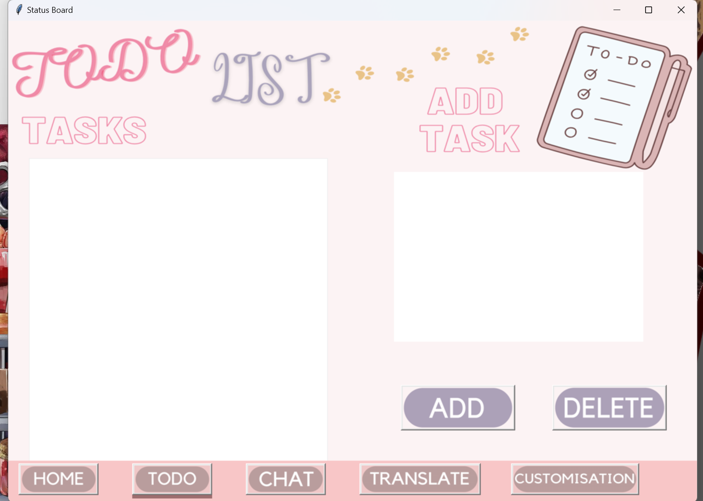 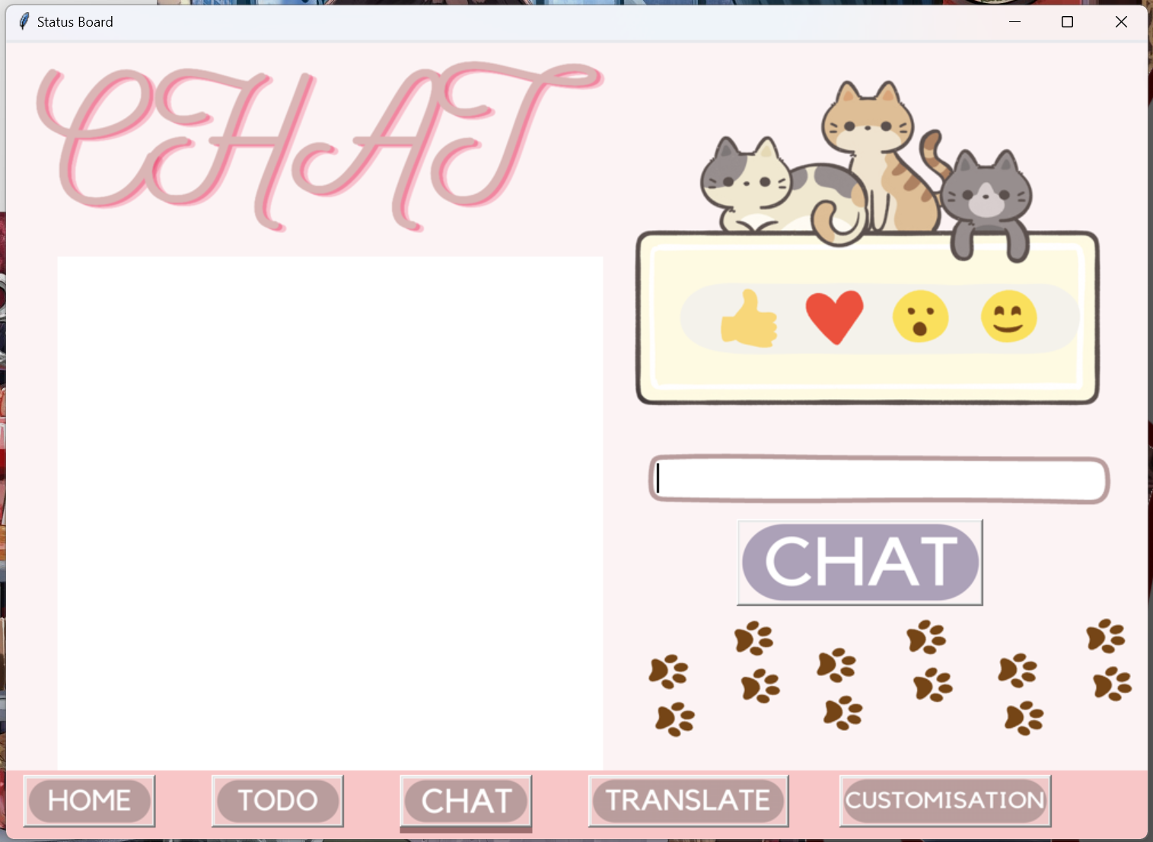

* The CHAT button invokes the chat page. (Remember to use a VPN if you are inside the Great Firewall since this function uses ChatGPT API)
* Type something and press the chat button. The page may freeze/lag for a few seconds before the conversation pops out in the left box.
* If you pressed enter, there may be a blank line input.
* Have a few conversations with the cat. You may notice that some conversations are not properly displayed. We will get this fixed!
* The TRANSLATE button invokes the translator page. (May require VPN: Google)
* You can choose languages for both text boxes.
* Wait a few seconds after clicking the translate button; the translated text appears in the right text box.
* The CLEAR button clears all the text in both text boxes.

* The CUSTOMISATION button invokes a blank page reserved for user customization of the appearance of the cat. Future updates!

# Other Bugs/Unchecked Exceptions

Try playing with the cat as you like. If you find some weird bugs, kindly provide us with a screenshot with a brief description of what happened. If not, congratulations! You have reached the end of our first user test. Do not forget to submit this form!

Again, thanks for your participation. Your support is very much appreciated!

ChocoRagdoll

25th June 2023